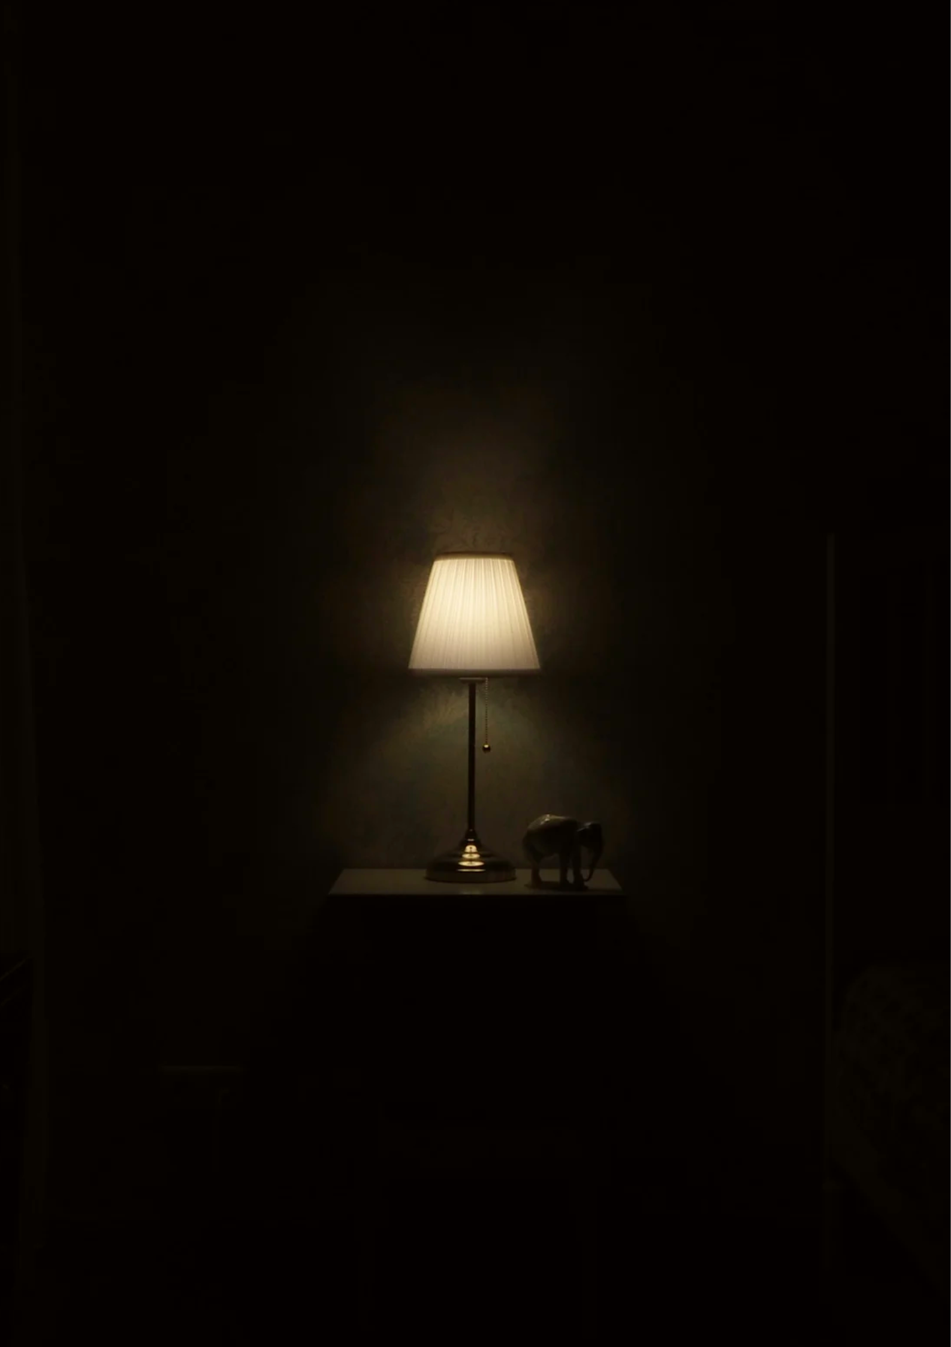
In Darkness
Let Me Dwell

Commemorating the life of Shakespearean singer-songwriter
John Dowland (1563-1636)
and his contemporaries

The Minstrels of Melodious Melancholy

Ingeborg Aadland & Marthe Aa - soprano/alto
Matthew Pope - tenor
James Tomlinson - bass & lute
Michael Fields - lute & director

5 March, 2026
7:30 pm

St. Mary the Virgin, Bathwick
Darlington Street, Bath BA2 4EB

Tickets £12 at the door

